Data Types Task
This extract of questionnaire contains four question using different types of data.

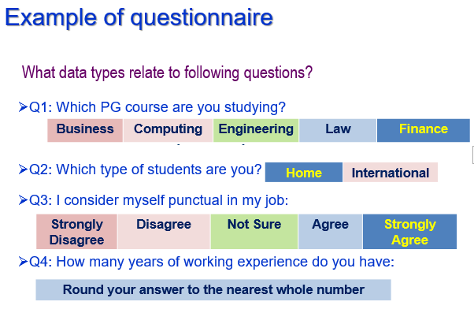

The answers are

