Dispersion

There are three measures of spread or dispersion to summarise data:
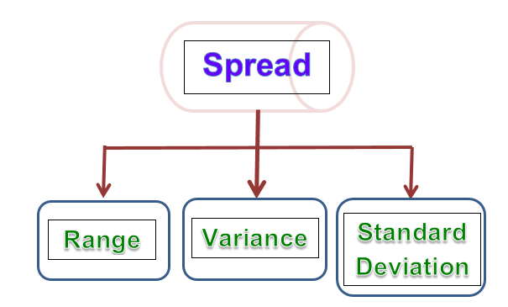
Spread flowchart

The range of a set of data is a measure of how the data is spread across the distribution.

