Averages

There are three averages to summarise data:
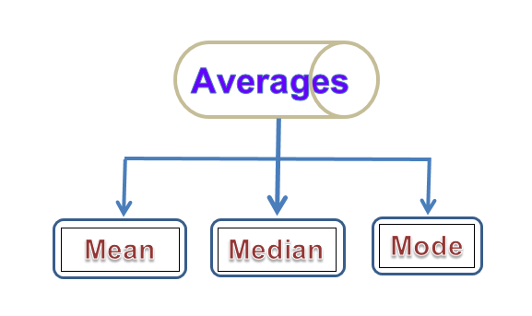
Averages flowchart

The mode or modal value in a set of data is the value that is more frequent.
The median is the middle value of a set of numbers arranged in order.
The mean of a set of values, equals the sum of all values, and then divided by the total number of values.
$Mean=\frac{Sum of values}{Number of values}$.

