Source Credibility Framework

Figure 1. Source credibility paradigms
Source
When?
Who?
Where?
How?
Value?

When?
- It is important to consider the time a source was published.
- Over time the credibility of theories will change therefore what was regarded as influential before may now be dated.
- When examining an older source, examine more recent research to establish relevance of findings.
Who?
- It is essential that you research the author to measure their authority and knowledge of the subject area.
- Before reading the source explore:
- Is the author a subject matter expert? If not, are they qualified to discuss the area they are reporting?
- Does the source contain details of the author’s credentials/qualifications?
- If you find an author is not an expert the accuracy or quality of what they discussed will be questionable.
Where?
- Where a source is published can determine its quality.
Questions:
- Is the source published in a well-established peer reviewed journal?
- If the source is not published in a peer-reviewed journal, how good is its publication location?
Resources such as Wikipedia may be a useful first source for information but do not constitute high quality publications.
How?
This is related to the methodology used for the research.
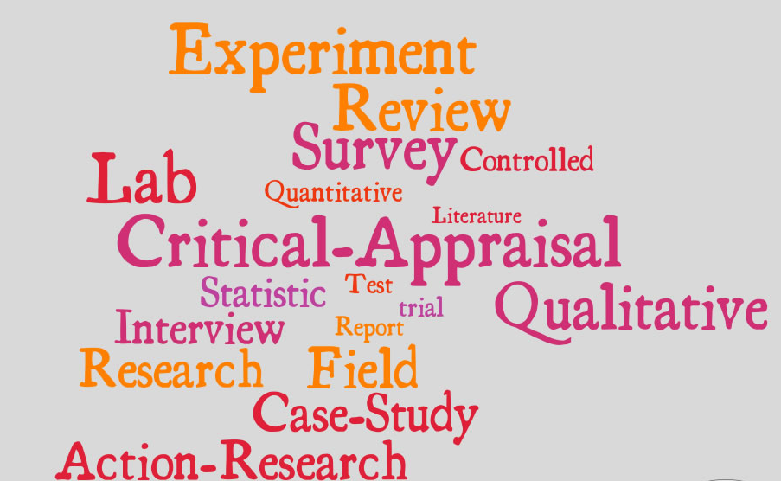
Value
For what can this research be used?
Is there anything specific about this research?
What implications does it have on current and future practice and/or theory?
How transferable is the research?
Figure 2. Source credibility marking grid
Credibility component | Comment | Score
When?
Who?
Where?
How?
Value

