Introduction to Quantitative Research Methods –
PCAI-Cycle Information sheet
Any quantitative research project follows the steps below, commonly known as PCAI-cycle. The cycle comprises four connected components as clockwise represented on the diagram.

Encourage students to explore, discuss and comment each component. To lead the discussion we can ask, for example, what is the importance of each step of the cycle? How are they connected. Then why are they important? How will students apply these steps to their project or for a critical review?

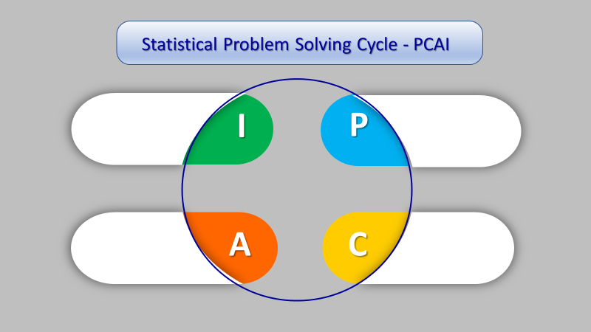 | 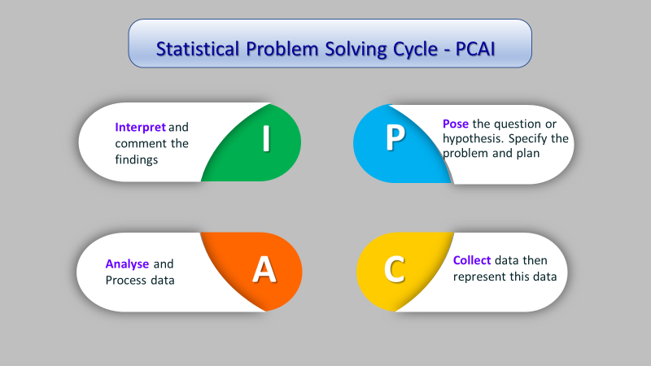

Suggested References
- The Higher Education Academy, Guide to Statistics: Supporting Statistics in Medicine. https://www.sheffield.ac.uk/polopoly_fs/1.43825!/file/Supporting-statistics.pdf
- Greenhalgh, T. (2014). Statistics for the non-statistician in How to read a paper: The Basics of Evidence-Based Medicine, 5th ed. John Wiley & Sons Ltd., pp. 60 – 77; 2nd edition open access https://www.ebcp.com.br/simple/upfiles/livros/001HTRP.pdf
- Rowntree, D. (2018) Statistics without tears: an introduction for non-mathematicians. 4th ed. London: Penguin Books.
- Teaching, Learning and Assessing Statistical Problem Solving http://jse.amstat.org/v17n1/marriott.htm

- Koohestani H.R et al. (2009) Barriers to the reporting of medication administration errors among nursing students, The Australian journal of advanced nursing, 27 (1), pp. 66-74

- Griffiths, C. et al. (2016) Effect of an education programme for south Asians with asthma and their clinicians: a cluster randomised controlled trial (OEDIPUS), PLoS ONE 11 (12) e0158783, and doi:10.1371/journal.pone. 0158783. pp. 1 – 16. Editor: Ji-Hyun Lee, UNM Cancer Centre USA. https://core.ac.uk/display/74226478 Open access article

- Zibaeenezhad, M.J., (2008) Association between periodontal disease and coronary artery disease, Central European Journal of Medicine, 3 (3), pp. 308-314

