Data Types

In statistics, it is essential to understand what types of data we are working with. There are several data types as shows the flowchart below.

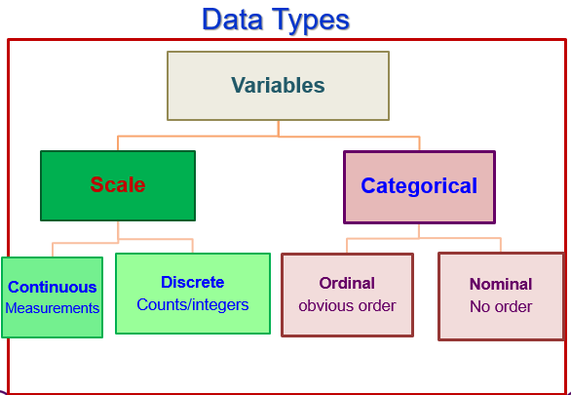
Data types’ flowchart
Definitions:
The term scale means numerical data, using numbers. The numerical data are two types.

If data represent counts of integer (whole) numbers (e.g. number of cars in the car park, number of bus stops, number of students in the class, number of modules, number of courses, number of classrooms, number teachers in the staff room, number of computers in the labs, etc… it is called discrete.

However, if data represent measurements such as size, length, height, width, weight, distance, time, cost, etc… it is called continuous. Continuous data is expressed by decimal numbers or fractions.

Categorical data is expressed by nouns, (e.g. countries, names of people, list of dishes, names of places, list of colours, etc…). The categorical data are two types. The above example data called nominal, because they cannot sorted except in the alphabetic order. If categorical data can be sorted it called ordinal such as Olympic Games medals (gold, silver, bronze), range of age (baby, child, infant, teenager, adult and elderly), medical staff according to their grades, months of the year, etc…

