Statistical problem-solving cycle

In order to carry out a research project or a statistical investigation, often we need to complete a statistical
Problem-solving cycle, commonly known as PCAI-cycle.

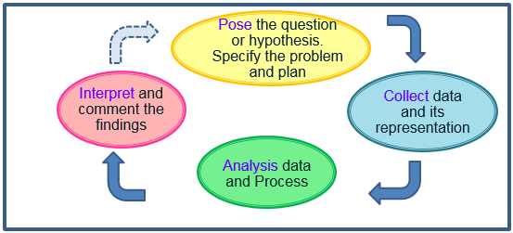
PCAI-cycle diagram

