Summary Statistics

There are two methods to summarise data:
  - Measures of central tendency (i.e. Measures of location or averages).
  - Measures of dispersion (i.e. Measures of spread).

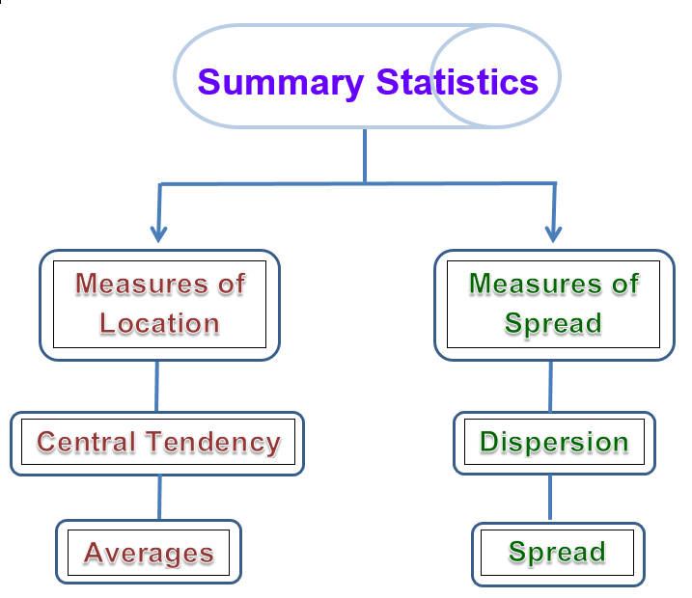
Summary Statistics flowchart

