Calculating Probabilities with the Normal distribution

Probabilities from the Normal distribution
Once a Normal distribution has been declared for a random variable we are able to use this distribution to find probabilities associated with the random variable. Suppose that $X$ is a random variable and we are to model it as $X \sim N\left(μ,σ^{2}\right)$. Then the probability that $X$ is between two values, $a$ and $b$ will be given by the area under the bell curve between $a$ and $b$. We call this $\operatorname{Pr}\left(a<X<b\right)$.

For example, if $X \sim N\left(3,1\right)$.

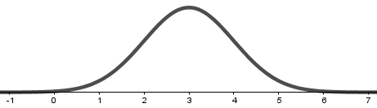

Then the probability that $X$ is between $2$ and $5$ is the area under the bell curve between $2$ and $5$.

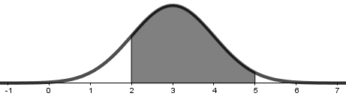

In this example, it turns out that $\operatorname{Pr}\left(2<X<5\right)≈0.82$, which is 82%.

It’s also possible to ask for one-sided probabilities, such as $\operatorname{Pr}\left(X>4\right)≈0.16=16\%$ and $\operatorname{Pr}\left(X<3.5\right)≈0.69=69\%.$

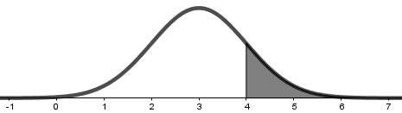

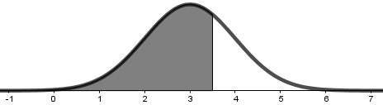

We can also ask for slightly more complicated probabilities, like $\operatorname{Pr}\left(\left|X-3\right|<2\right)≈0.95=95\%$ and $\operatorname{Pr}\left(\left|X-4\right|>1\right)≈0.52=52\%$.

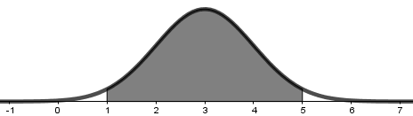

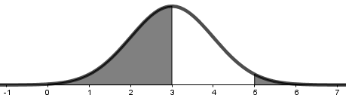

How can we actually calculate these probabilities? Unfortunately, we can’t use any simple techniques to calculate the area under a bell curve, we must resort to numerical approximation techniques. Luckily, in this modern age, there are many options for calculating these probabilities.

Method 1 Mobile Phone App
There are a multitude of mobile phone apps that can calculate Normal probabilities. One such app is Matthew Bognar’s free Probability Distributions app, available on Google Play and the iPhone App Store.

Let’s look at how to find $\operatorname{Pr}\left(2<X<5\right)$ if $X \sim N\left(3,1\right)$.

First open the app and select the Normal distribution.

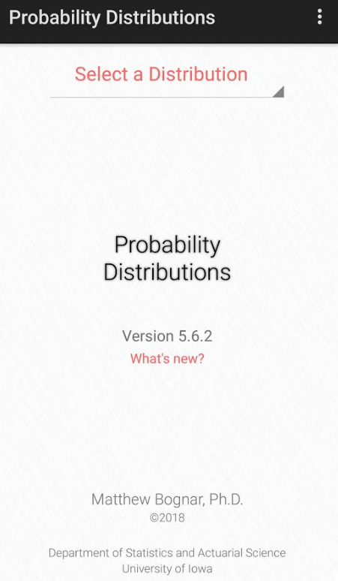
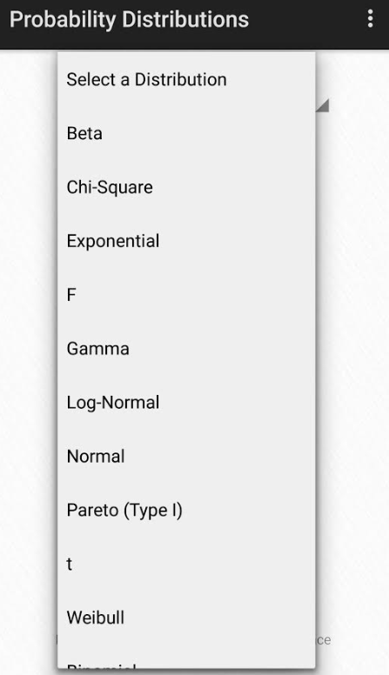

Choose the appropriate value for $μ$ and $σ$. Note that this app wants to know $σ$ only, not $σ^{2}$ which is the value used in the declaration of the Normal distribution. For example, if $X \sim N\left(5,4\right)$ then $σ=2$. In this case, with $X \sim N\left(3,1\right)$, $σ^{2}=1$ and $σ=1$ also.

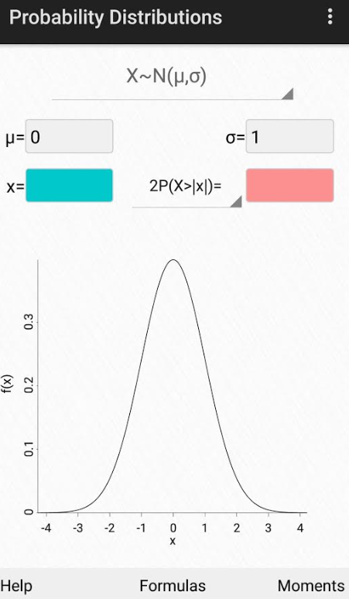
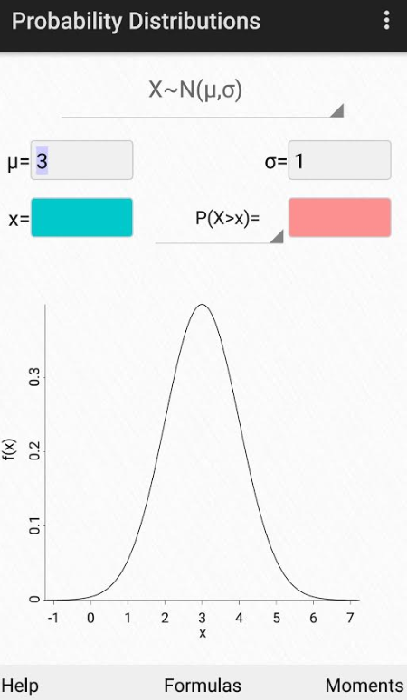

Make sure that P(X>x) is selected. This means that the app will calculate $Pr⁡(X>x)$ when you place $x$ in the blue box on the left.

Since the app can only provide $\operatorname{Pr}\left(X>x\right)$, we need to slightly manipulate the probability we are after. We note that$\operatorname{Pr}\left(2<X<5\right)=\operatorname{Pr}\left(X>2\right)-Pr⁡(X>5)$. These two probabilities can now be found with the app.

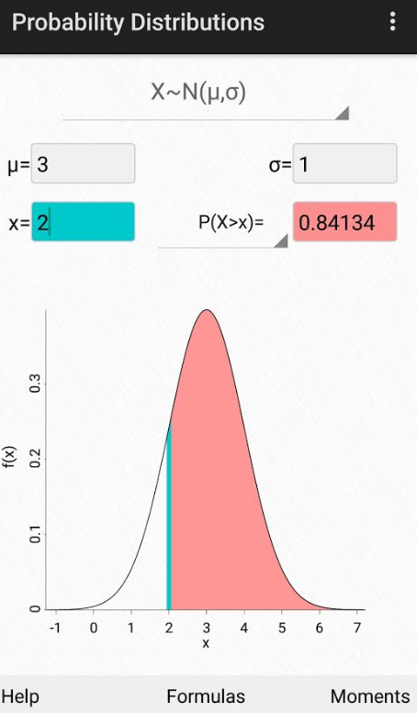
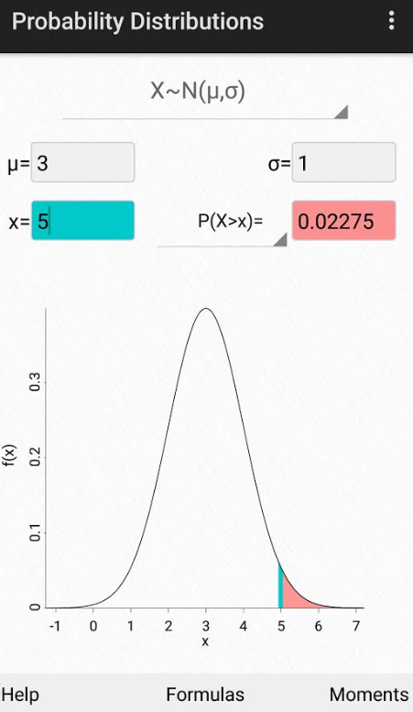

Using these value, we are able to complete the calculation. $\operatorname{Pr}\left(2<X<5\right)=\operatorname{Pr}\left(X>2\right)-\operatorname{Pr}\left(X>5\right)≈0.84134-0.02275=0.81859$.

Method 2 Computer Software
There any many specific mathematical and statistical software packages such as R, SPSS, Minitab, Matlab, GeoGebra, etc, that can provide probability calculations for the Normal distribution. Some are free, some will be available under licences to your university, but others will require a purchase.

An alternative to all of these is Microsoft Excel, which comes with a special function NORMAL.DIST. To use this function, simply type

=NORMAL.DIST(

into any cell of an Excel worksheet. If you’re using a recent version of Excel, it should prompt you to supply four inputs; x, mean, standard_dev, cumulative.

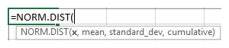

- x is the value of $X$ that you are interested in
- mean is the value of the mean of $X$, $μ$
- standard_dev is the value of the standard deviation of $X$, $σ$; note this is not the variance, $σ^{2}$
- cumulative needs to be set to TRUE, this produces a cumulative probability from the left tail

Here are some examples.

NORMAL.DIST(1,2,3,TRUE) will produce $\operatorname{Pr}\left(X<1\right)$ where $X \sim N\left(2,9\right)$
NORMAL.DIST(3,1,2,TRUE) will produce $\operatorname{Pr}\left(X<3\right)$ where $X \sim N\left(1,4\right)$
NORMAL.DIST(-2,0,1,TRUE) will produce $\operatorname{Pr}\left(X<-2\right)$ where $X \sim N\left(0,1\right)$
NORMAL.DIST(2,-1,0.5,TRUE) will produce $\operatorname{Pr}\left(X<2\right)$ where $X \sim N\left(-1,0.25\right)$

In order to calculate a more complicated probability. For example, if $X \sim N(3,1)$, then

$$\operatorname{Pr}\left(X>4\right)=1-\operatorname{Pr}\left(X<4\right)=1-\text{NORMAL.DIST(4,3,1,TRUE)}≈1-0.8413=0.1587$$

Alternatively,

$$\operatorname{Pr}\left(X>4\right)=\operatorname{Pr}\left(X<2\right) due to symmetry about μ=3=\text{NORMAL.DIST(2,3,1,TRUE)}≈0.1587$$

$$\operatorname{Pr}\left(2<X<5\right)=\operatorname{Pr}\left(X<5\right)-\operatorname{Pr}\left(X<2\right)=\text{NORMAL.DIST(5,3,1,TRUE)}-\text{NORMAL.DIST(2,3,1,TRUE)}≈0.9772-0.1587=0.8185$$

$$\operatorname{Pr}\left(\left|X-3\right|<2\right)=\operatorname{Pr}\left(-2<X-3<2\right)=\operatorname{Pr}\left(1<X<5\right)=2\operatorname{Pr}\left(3<X<5\right) due to symmetry about μ=3=2\left[\operatorname{Pr}\left(X<5\right)-\operatorname{Pr}\left(X<3\right)\right]=2\left[\operatorname{Pr}\left(X<5\right)-0.5\right] as\operatorname{Pr}\left(X<μ\right)=0.5=2\left[\text{NORMAL.DIST(5,3,1,TRUE)}-0.5\right]≈2\left[0.9772-0.5\right]=0.9544$$

$$\operatorname{Pr}\left(\left|X-4\right|>1\right)=\operatorname{Pr}\left(X-4<-1\right)+\operatorname{Pr}\left(X-4>1\right)=\operatorname{Pr}\left(X<3\right)+\operatorname{Pr}\left(X>5\right)=0.5+\operatorname{Pr}\left(X>5\right) as\operatorname{Pr}\left(X<μ\right)=0.5=0.5+1-\text{NORMAL.DIST(5,3,1,TRUE)}≈1.5-0.9772=0.5228$$

Method 3 Ask the Internet
A quick little Google of the search term normal probability calculator gives a multitude of online calculators.

For example, the OnlineStatBook Normal probability calculator (link) is very flexible; it allows you to calculate Normal probabilities very directly.

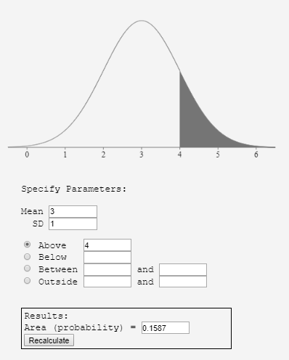

Here we calculate $\operatorname{Pr}\left(X>4\right)$ if $X \sim N\left(3,1\right)$.

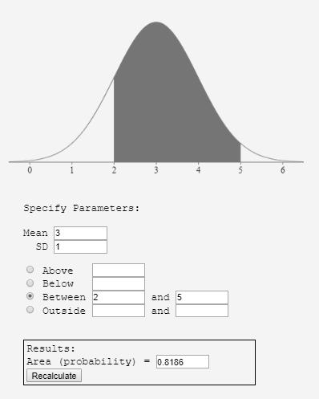

Here we calculate $\operatorname{Pr}\left(2<X<5\right)$ if $X \sim N\left(3,1\right)$.

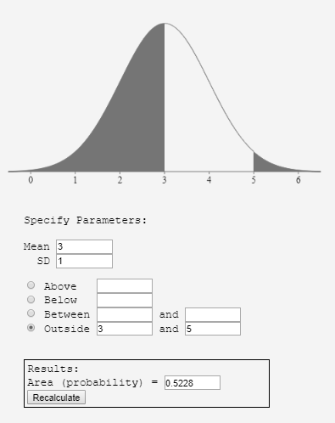

And here we calculate $\operatorname{Pr}\left(|X-4|>1\right)$ if $X \sim N\left(3,1\right)$.

Method 4 Graphics Calculator
If you have a graphics calculator, then you might have access to special functions for probability distributions. For example, the Texas Instruments TI-83 Plus calculator has a DISTRIBUTIONS menu that you can access by pressing 2nd + DIST.

The first three functions are based on the Normal distribution.

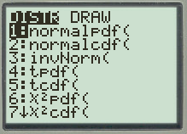

For calculating probabilities, we want to use normalcdf (which stands for Normal cumulative distribution function). The format required is normalcdf($μ$,$σ$,$x$) and this will calculate $Pr⁡(X<x)$ where $X \sim N\left(μ,σ^{2}\right)$. It’s similar in set-up to the Microsoft Excel function.

Here are some examples.

normalcdf(1,2,3) will produce $\operatorname{Pr}\left(X<1\right)$ where $X \sim N\left(2,9\right)$
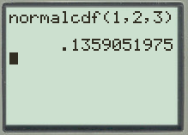

normalcdf(3,1,2) will produce $\operatorname{Pr}\left(X<3\right)$ where $X \sim N\left(1,4\right)$
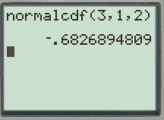

normalcdf(-2,0,1) will produce $\operatorname{Pr}\left(X<-2\right)$ where $X \sim N\left(0,1\right)$
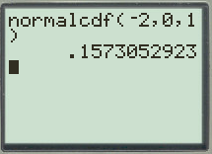

normalcdf(2,-1,0.5) will produce $\operatorname{Pr}\left(X<2\right)$ where $X \sim N\left(-1,0.25\right)$
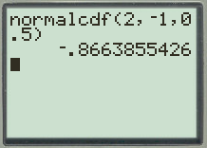

For any probabilities not in the $\operatorname{Pr}\left(X<x\right)$ format, you will need to make similar adjustments as mentioned previously.

Method 5 Statistical Tables
This method is not as useful as it once was before the onset of modern computing. However, it is still important to know how to use statistical tables to calculate Normal probabilities.

Firstly, it is obviously not possible to create lists of Normal probabilities for all combinations of $μ$ and $σ$ and so most tables only list probabilities for what’s called the standard Normal distribution, $N\left(0,1\right)$. We often use the letter $Z$ to represent the standard Normal random variable, such that $Z \sim N\left(0,1\right)$.

In order to calculate probabilities with respect to generic Normal random variable, $X \sim N\left(μ,σ^{2}\right)$, we use the transformation

$$Z=\frac{X-μ}{σ}.$$

This is often described as normalising the random variable $X$ to $Z$. A nice property of the Normal distribution is that all probabilities will be maintained with respect to the variables’ individual means and standard deviations.

For example, if $X \sim N\left(6,4\right)$ ($μ=6$ and $σ=2$) and $Z \sim N\left(0,1\right)$ ($μ=1$ and $σ=1$), then

$\operatorname{Pr}\left(X<6\right)=Pr(Z<0)$ The probability each variable is less than its $μ$
$\operatorname{Pr}\left(X>8\right)=\operatorname{Pr}\left(Z>1\right)$ The probability each variable is more than 1$σ$ above its $μ$
$\operatorname{Pr}\left(2<X<10\right)=\operatorname{Pr}\left(-2<Z<2\right)$ The probability each variable is within $2σ$ of its $μ$

Each of these equalities can be achieved with the transformation $Z=\frac{X-μ}{σ}.$

$$\operatorname{Pr}\left(X<6\right)=\operatorname{Pr}\left(\frac{X-μ}{σ}<\frac{6-6}{2}\right)=\operatorname{Pr}\left(Z<0\right)=look this up on a standard Normal table$$

$$\operatorname{Pr}\left(X>8\right)=\operatorname{Pr}\left(\frac{X-μ}{σ}>\frac{8-6}{2}\right)=\operatorname{Pr}\left(Z>1\right)=look this up on a standard Normal table$$

$$\operatorname{Pr}\left(2<X<10\right)=\operatorname{Pr}\left(\frac{2-6}{2}<\frac{X-μ}{σ}<\frac{10-6}{2}\right)=\operatorname{Pr}\left(-2<Z<2\right)=look this up on a standard Normal table$$

The second step is to look up these probabilities in terms of $Z$ on a statistical table. These statistical tables, unfortunately, come in many forms and so it’s important to check exactly what they will do.

Some statistical tables only give left-tail probabilities less than 50%.
Table 1
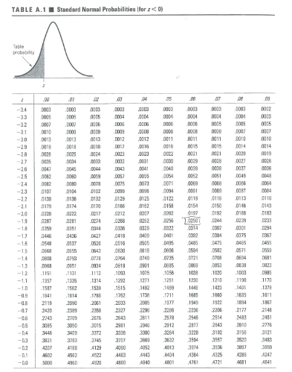

Some statistical tables only give right-tail probabilities less than 50%.
Table 2
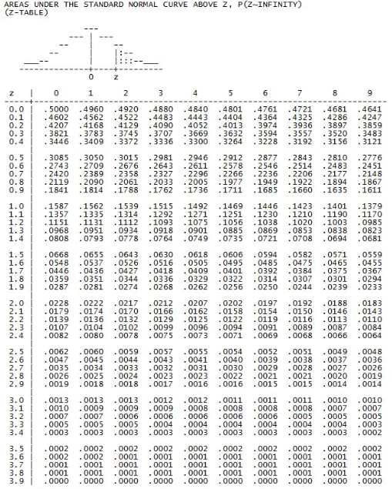
Some statistical tables only give left-tail probabilities greater than 50%.
Table 3
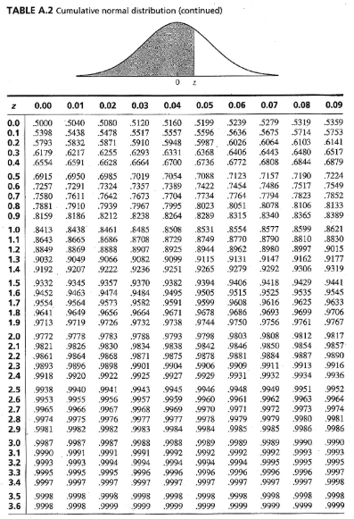

Some statistical tables only give probabilities from $0$ to a positive value of $Z$.
Table 4
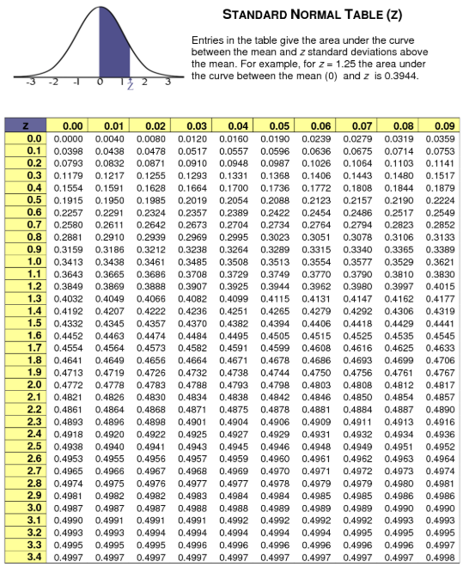
Either way, you will simply need to manipulate the probabilities you seek into the format required of the table you are using. You can do this by either using symmetry, or the fact that complementary values must add to $100\%$.

For example, suppose $X \sim N\left(3,1\right)$ and we wish to calculate $Pr⁡(2<X<5)$. We first normalise a random variable.

$$\operatorname{Pr}\left(2<X<5\right)=\operatorname{Pr}\left(\frac{2-3}{1}<\frac{X-μ}{σ}<\frac{5-3}{1}\right)=\operatorname{Pr}\left(-1<Z<2\right)$$

If we were using Table 1, which requires left-tail probabilities less than 50%,
We would rearrange to the following.

$$\operatorname{Pr}\left(2<X<5\right)=\operatorname{Pr}\left(-1<Z<2\right)=\operatorname{Pr}\left(Z<2\right)-\operatorname{Pr}\left(Z<-1\right)=1-\operatorname{Pr}\left(Z>2\right)-\operatorname{Pr}\left(Z<-1\right)=1-\operatorname{Pr}\left(Z<-2\right)-\operatorname{Pr}\left(Z<-1\right)≈1-0.0228-0.1587=0.8185$$

If we were using Table 2, which requires right-tail probabilities less than 50%.

We would rearrange to the following.

$$\operatorname{Pr}\left(2<X<5\right)=\operatorname{Pr}\left(-1<Z<2\right)=\operatorname{Pr}\left(Z>-1\right)-\operatorname{Pr}\left(Z>2\right)=1-\operatorname{Pr}\left(Z<-1\right)-\operatorname{Pr}\left(Z>2\right)=1-\operatorname{Pr}\left(Z>1\right)-\operatorname{Pr}\left(Z>2\right)≈1-0.1587-0.0228=0.8185$$

If we were using Table 3, which requires left-tail probabilities greater than 50%.

We would rearrange to the following.

$$\operatorname{Pr}\left(2<X<5\right)=\operatorname{Pr}\left(-1<Z<2\right)=\operatorname{Pr}\left(Z<2\right)-\operatorname{Pr}\left(Z<-1\right)=\operatorname{Pr}\left(Z<2\right)-\operatorname{Pr}\left(Z>1\right)=\operatorname{Pr}\left(Z<2\right)-\left[1-\operatorname{Pr}\left(Z<1\right)\right]=\operatorname{Pr}\left(Z<2\right)+\operatorname{Pr}\left(Z<1\right)-1≈0.9772+0.8413-1=0.8185$$

If we were using Table 4, which requires probabilities from $0$ to a positive value of $Z$.

We would rearrange to the following.

$$\operatorname{Pr}\left(2<X<5\right)=\operatorname{Pr}\left(-1<Z<2\right)=\operatorname{Pr}\left(-1<Z<0\right)+\operatorname{Pr}\left(0<Z<2\right)=\operatorname{Pr}\left(0<Z<1\right)+\operatorname{Pr}\left(0<Z<2\right)≈0.3413+0.4772=0.8515$$

Activity
Using the method of your choice, calculate the following probabilities.

- $\operatorname{Pr}\left(X>2\right)$ where $X \sim N\left(1,1\right)$
- $\operatorname{Pr}\left(X<3\right)$ where $X \sim N\left(4,4\right)$
- $\operatorname{Pr}\left(X>-1\right)$ where $X \sim N\left(0,9\right)$
- $Pr⁡(X<0)$ where $X \sim N\left(-2,4\right)$
- $\operatorname{Pr}\left(X>60\right)$ where $X \sim N\left(50,100\right)$
- $Pr(X<1750)$ where $X \sim N\left(1500,10000\right)$
- $Pr(6<X<8)$ where $X \sim N\left(5,9\right)$
- $\operatorname{Pr}\left(-3<X<-1\right)$ where $X \sim N\left(0,25\right)$
- $\operatorname{Pr}\left(0<X<2\right)$ where $X \sim N\left(1.5,16\right)$
- $\operatorname{Pr}\left(-5<X<2\right)$ where $X \sim N\left(1,36\right)$
- $Pr⁡(-10<X<20)$ where $X \sim N\left(10,1600\right)$
- $\operatorname{Pr}\left(2000<X<3000\right)$ where $X \sim N\left(2000,1000000\right)$
- $\operatorname{Pr}\left(\left|X\right|<4\right)$ where $X \sim N\left(-2,100\right)$
- $\operatorname{Pr}\left(\left|X-1\right|<1\right)$ where $X \sim N\left(1,9\right)$
- $Pr\left(\left|X\right|>10\right)$ where $X \sim N\left(0,121\right)$
- $\operatorname{Pr}\left(\left|X+2\right|>3\right)$ where $X \sim N\left(-3,9\right)$

