Group Work 1 – Information Sheet
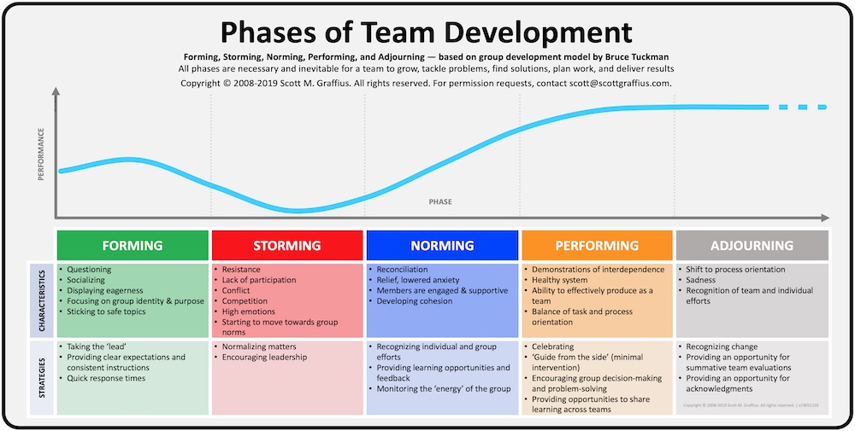
(Source: Agile Scrum Guide, 2018)

