Introduction to Statistics
Setting: | Seminar, class size approximately of 30.
Preparation duration: | 40 - 50 minutes.
Level: | Levels 4 - 7
Activity duration: | 50 - 60 minutes.
Additional guidance: | Lecturer might to refer to one published research paper related to a statistical investigation, (e.g. one of the articles mentioned in references 5 – 7) and try to identify and highlight the four stages of such inquiry.
Outcomes:
- Students will learn about the statistical problem-solving cycle.
- Students will be able to list the four phases of the statistical problem-solving cycle, known as PCAI-cycle.
- Students will be able to realise the necessity of the four phases of the PCAI-cycle for any a statistical investigation project.
- Students will be able to describe briefly the four phases of the statistical problem-solving cycle.
Pre-task preparation:
- Page 3 of the reference 1 or reference 4 both provide introduce a brief introduction to the statistical problem solving cycle.
- The reference 4 is on “Teaching, Learning and Assessing Statistical Problem Solving” http://jse.amstat.org/v17n1/marriott.html
- Watch a video clip
https://www.coursera.org/lecture/evaluating-problems/statistics-and-problem-solving-wcBGQ
- Chapter 5 of the reference 2 covers “Statistics for the non-statisticians”. It is an overview of contents of a statistical research article.
- Further details in reference 3, showing how Statistics works and powerful ideas behind it.

Steps to implement the activity:
- Set the learning objectives of the session.
- Introduce Statistics through a practical approach: the statistical problem-solving cycle.
- Divide the students into small groups of 2 to 3 people.
- After examining the page 3 of reference 1, or searching in the internet the “statistical problem-solving cycle” definition, ask students to provide a complete description of the PCAI-cycle.
- Students will be working together to complete their diagrams and sharing information.
- Students have to write down (on A3 paper sheet or flip chart) the definition of all four stages of the PCAI-cycle.
- Students will display their findings, turning around, sharing information and observe their peers’ outcomes. They will compare and discuss the findings.
- Summarize the information displayed.
- Students to perform the first phase of either their individual project or a suggested topic by the tutor.
- Conduct an open discussion allowing students to introduce their current or future individual project

Guidance for the tutor
A quantitative research project or a statistical inquiry requires often following the statistical problem-solving cycle, commonly known as PCAI-cycle. The cycle includes four connected components as summarised on the graph below.

Encourage students to explore, discuss and comment each component of the graph below. To lead the discussion we ask, for example, what is the importance of each step of the cycle? Then why it is important? How will they apply these steps to their project?

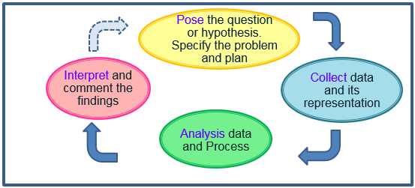
PCAI-cycle diagram

References
- The Higher Education Academy, Guide to Statistics: Supporting Statistics in Medicine. https://www.sheffield.ac.uk/polopoly_fs/1.43825!/file/Supporting-statistics.pdf
- Greenhalgh, T. (2014). Statistics for the non-statistician in How to read a paper: The Basics of Evidence-Based Medicine, 5th ed. John Wiley & Sons Ltd., pp. 60 – 77; 2nd edition open access https://www.ebcp.com.br/simple/upfiles/livros/001HTRP.pdf
- Rowntree, D. (2018) Statistics without tears: an introduction for non-mathematicians. 4th ed. London: Penguin Books.
- Teaching, Learning and Assessing Statistical Problem Solving http://jse.amstat.org/v17n1/marriott.html

- Koohestani H.R et al. (2009) Barriers to the reporting of medication administration errors among nursing students, The Australian journal of advanced nursing, 27 (1), pp. 66-74
- Griffiths, C. et al. (2016) Effect of an education programme for south Asians with asthma and their clinicians: a cluster randomised controlled trial (OEDIPUS), PLoS ONE 11 (12) e0158783, and doi:10.1371/journal.pone. 0158783. pp. 1 – 16. Editor: Ji-Hyun Lee, UNM Cancer Centre USA. https://core.ac.uk/display/74226478 Open access article
- Zibaeenezhad, M.J., (2008) Association between periodontal disease and coronary artery disease, Central European Journal of Medicine, 3 (3), pp. 308-314

