Working in Teams Reflection

It’s useful to reflect on your previous participation in group/team work to inform how you can improve your productivity in future tasks.
Perform reflection by answering the questions below relating to your participation when working in a team.
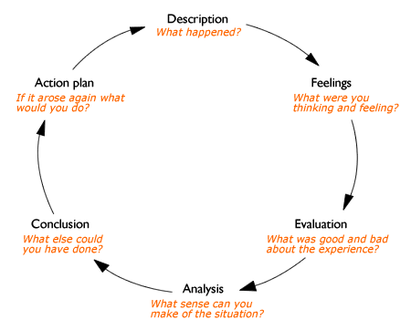
Gibb’s (1988) reflective cycle
What role(s) did you take when working in a team?

How did you feel about the role(s) you took?

Were you comfortable with your role(s)?

Do you believe the role(s) was suitable for you?

Did your team perform well?

How would you rate your participation in the group?

What were the strengths of your group/team?

What areas needed improvement in relation to team work?

Thinking ahead
What would you do differently at the planning stage of group work?

Would you take up a similar role in the future or do you think an alternative role would be more suitable for you?

In relation to communicating your ideas how do you think you can be more effective?

